https://youtu.be/RkYIWg5XAnI
Email id-projectminor22@gmail.com
password-Technointernational@2025
Do not add anything any error in this code

Build and Deploy a Full Stack AI SaaS App using React js | Complete PERN Stack Project
👉 Clerk: https://go.clerk.com/GHwC6Yp
👉 Neon: https://get.neon.com/XZ88lhE
👉 Live Preview: https://quickai-gs.vercel.app/
👉 Source code & assets: https://greatstack.dev/p/quickai
👉 Figma: https://www.figma.com/design/AFlvuDrbIKBsQTI75HHOC9/QuickAI?node-id=0-1&p=f

https://chatgpt.com/c/68bd77a1-d1d8-8325-82ca-1253a5d62ca2
https://chat.deepseek.com/a/chat/s/5484657d-9726-4387-b290-14179db28f5f

https://prebuiltui.com/
Describe
In this tutorial, we will guide you through the process of building and deploying a fully functional AI SaaS Application with Subscriptions billings using the PERN stack (PostgreSQL, Express, React and Node.js). Key Features: User Authentication: Secure sign-in, sign-up and profile management using Clerk Subscription Billing: Premium subscriptions to access premium AI features PostgreSQL Database: Serverless postgres Database by Neon AI features: Article Generator: Provide Title & length to generate article using AI Blog Title Generator: Provide Keyword and category to generate blog titles Image Generator: Provide prompt to generate images using AI Background remover: Upload image and get transparent background image using AI Image object remover: upload image and describe the object name to be removed from any image Resume Analyzer: Upload resume and get complete analysis of your resume using AI
AI SaaS App Project Setup Summary
Based on your terminal session, here's what was accomplished:

Project Creation
✅ Created a new Vite project named "client"

✅ Selected React framework with JavaScript variant

✅ Project scaffolded successfully in E:\AI SaaS App\client

Dependencies Installed
✅ React (via Vite scaffolding)

✅ React Router DOM (for navigation)

✅ Lucide React (for icons)

Development Server
✅ Started development server on http://localhost:5173/

✅ Vite v7.1.4 ready in 389ms

Font outfit

https://www.figma.com/design/AFlvuDrbIKBsQTI75HHOC9/QuickAI?node-id=0-1&p=f

https://dashboard.clerk.com/apps/app_32NPpgQM6y1g8XH8vEEPoZx1Jiz/instances/ins_32NPpgqVtmL1gEBKnoctZIUKPPH/billing/plans?tab=user

Day 1- 1:00:00 ✅
Day 2- 2:00:00 ✅ (faced too many errors but made it😭)
Day 3- 2:20:00 ✅
Day 4- 3:20:00 ✅ (frontend done)
Day 5- 4:35:00 ✅
Day 6- 5:40:00 ✅ (struggling w alot of errors in the backend, taking so much time to resolve😭)
Day 7- DONE AND DEPLOYED✅ cant wait to put it on my portfolio 🥹

npm install react-markdown installs the React Markdown library that lets you safely render Markdown content as React components.
Here’s each package explained in about 30 words each:

1. express
Express is a fast, minimal, and flexible Node.js framework for building web applications and APIs. It provides routing, middleware support, request/response handling, and simplifies server-side development significantly.

2. dotenv
Dotenv loads environment variables from a .env file into process.env. It helps manage sensitive credentials (like API keys, database URLs) securely and keeps configuration separate from source code.

3. cors
CORS (Cross-Origin Resource Sharing) is Express middleware that enables or restricts resource requests from different domains. It controls security by allowing frontend apps to communicate safely with backend servers.

4. axios
Axios is a promise-based HTTP client for Node.js and browsers. It simplifies sending asynchronous HTTP requests, handling responses, errors, and supports features like interceptors, JSON parsing, and automatic transformations.

5. cloudinary
Cloudinary is a cloud-based service for managing, uploading, and optimizing images and videos. It provides APIs for transformation, compression, delivery via CDN, and reduces media management workload for developers.

6. multer
Multer is a Node.js middleware for handling multipart/form-data used for uploading files. It processes incoming files, stores them temporarily or permanently, and integrates seamlessly with Express applications.

You wrote the package names a little incorrectly 🙂. The correct command is:
npm install express dotenv cors axios cloudinary multer
✅ Notes:
- cloudnary → correct spelling is cloudinary
- muiter → correct spelling is multer
Neon
https://console.neon.tech/app/projects/silent-shadow-63374650?database=neondb
https://neon.com/docs/guides/express
https://clerk.com/docs/quickstarts/express

https://dashboard.clerk.com/apps/app_32NPpgQM6y1g8XH8vEEPoZx1Jiz/instances/ins_32NPpgqVtmL1gEBKnoctZIUKPPH/billing/plans?tab=user
https://neon.com/docs/use-cases/use-cases-overview

ai
https://aistudio.google.com/projects
http://ai.google.dev/gemini-api/docs/openai

niladrib657@gmail.com
https://dashboard.clerk.com/apps/app_32NPpgQM6y1g8XH8vEEPoZx1Jiz/instances/ins_32NPpgqVtmL1gEBKnoctZIUKPPH/users/user_34c9XJgjyQuHjVAjpQG4awxz0vj?user_back_page=users
4.24.50

https://clipdrop.co/apis/docs/cleanup
work on
D:\AI SaaS App\server\controllers\aiController.js

https://chatgpt.com/c/68fe2f0a-1498-8322-b6c5-bea6ebc9a8ea
https://chat.deepseek.com/a/chat/s/5484657d-9726-4387-b290-14179db28f5f

CLIPDROP_API_KEYCLIPDROP_API_KEY
https://clipdrop.co/apis/account

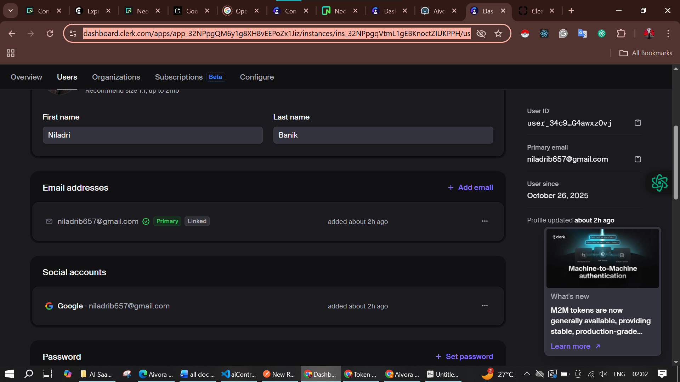

Add env in CLIPDROP_API_KEY
And after this I can work on generateImage this in D:\AI SaaS App\server\controllers\aiController.js

cloudinary
https://console.cloudinary.com/app/c-7790dda87b337a0d73eaf80fca8944/settings/api-keys

4.38.05
In this case the image not working so rewrite the all the step
https://clipdrop.co/apis/account

POST http://localhost:3000/api/ai/generate-article
{
"prompt": "a girl",
"length": 2000
}

generate-image
POST http://localhost:3000/api/ai/generate-image
{
"prompt": "a girl",
"publish": true
}

5.03.20 this is the end point
D:\AI SaaS App\client\src\pages\WriteArticle.jsx

5.27.06

5.37.52

Image
https://pollinations.ai/

which one is better work what you think

6.23.19
database
https://console.neon.tech/app/projects/silent-shadow-63374650/branches/br-wispy-base-a8wlz216/tables
claude
https://claude.ai/chat/73ba910e-bc29-4087-a7fc-abe029da3972

https://claude.ai/chat/32c57a7a-86ad-492d-b307-688fa6401c0a
generate Article
https://console.groq.com/keys

https://www.canva.com/design/DAG7wjIWLcY/WrTUuF6tSEKD4c3naPkR1g/edit?ui=eyJEIjp7IkoiOnsiRCI6eyJBPyI6IkEifX19fQ

https://www.canva.com/design/DAG7wltZIVE/yVWTnbaDDomE1el7zxaObA/edit?ui=eyJEIjp7IkoiOnsiRCI6eyJBPyI6IkEifX19fQ

bolt
https://bolt.new/~/sb1-g8gtn975

https://www.figma.com/make/C6eZWHkFTHKEOpkJmNC8mV/Simple-AI-SaaS-Landing-Page?t=VyoKJxiFZXYgNU4t-0

https://claude.ai/chat/b5a5ef71-b983-4e54-b2bd-fe97fa397ac4

cloudinary
https://console.cloudinary.com/app/c-7790dda87b337a0d73eaf80fca8944/assets/media_library/search?q=&view_mode=mosaic

